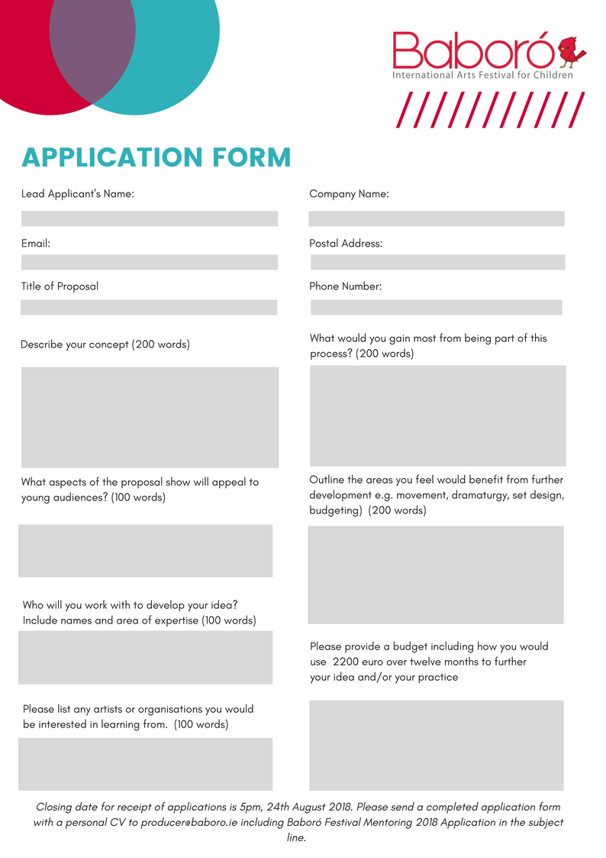

Enter Text

Enter Text

Enter Text

Enter Text

Enter Text

Enter Text

Enter Text

Enter Text

Enter Text

Enter Text

Enter Text

Enter Text

Enter Text

Enter Text